December 1, 2020
#GivingTuesdayNM
Together we can do more

#GivingTuesdayNM

Ideas for Nonprofits,
Schools and Grantmakers

Ideas for Nonprofits

- Solicit matching grants.
  - Many donors work at companies that will match donations made by their employees. Encourage your donors to submit matching gift requests.
  - Ask your board to support a matching gift to incentivize new or larger donations.
- Solicit a local business.
  - Some ideas for how a business can give back:
    - Donate a percentage of proceeds from the day's sales.
    - Donate proceeds from the sales of a particular item.
    - Host your organization on #GivingTuesdayNM for a fundraising event.
    - Their staff can do a volunteer project with your organization.
    - Their staff can collectively contribute to your organization.
  - Let us know if you secure a partnership with a local business so we can promote social media!
- Make sure your constituents know your nonprofit is part of this movement.
  - Use social media to leverage your #GivingTuesdayNM campaign. Use the hashtag often on Twitter, Facebook and Instagram.
- Integrate #GivingTuesdayNM into your end-of-year fundraising campaign.
  - Use this day as an opportunity to try a new strategy to close end of year gifts.
- Consider mobile or online giving.
  - #GivingTuesdayNM is a great day to engage your online community and transform followers and fans into donors.
- Organize a volunteer project for your organization.
  - Invite donors, employees and your neighbors to get together to celebrate giving by creating a day of service.
  - Obtain skilled volunteers through New Mexico Volunteer Connection.
- Share your story!
  - While #GivingTuesdayNM is doing press for the entire coalition, consider reaching out to media outlets to spread the word about your nonprofit.
  - Remember, we are leveraging the power of collaboration, so be sure to say that your nonprofit is part of the statewide coalition #GivingTuesdayNM!

Ideas for Schools

- Launch a school-wide giving day.
  - UNM launched #LobosGiveDay in 2015.
  - The University of Michigan has #GivingBlueDay, also launched in 2015.
- Seek a matching grant.
  - In 2015, New Mexico State University (NMSU) partnered with the Hunt Family Foundation on a matching campaign for scholarship funds. Their #GivingTuesday campaign added a total of $5.7 million to the university’s scholarship fund.
- Utilize social media leading up to and on #GivingTuesdayNM.
  - Encourage students to support a cause they care about on December 1st.
- Appoint #GivingTuesdayNM student ambassadors.
  - They can help bring together groups to promote #GivingTuesdayNM on campus.
- Host an on-campus volunteer fair on #GivingTuesdayNM for student groups and potential nonprofit employers.
- Announce a new fundraising initiative.
  - For example, Northwood University used #GivingTuesday to announce their capital campaign.
- Engage parents and alumni.
  - For example, Arizona State University had great success by securing a matching grant from a proud mom.
- Engage professors.
  - Start a discussion about philanthropy and volunteerism, and what students would like to see more of on campus related to giving.
- Present an award to a student leader on #GivingTuesdayNM.
- Contact your department dean and ask about pro bono projects for students.

Ideas for Grantmakers

Why Support #GivingTuesdayNM
- To assist grantees in gaining more support.
- To leverage opportunities to partner with grantees.
- To collaborate with other funders and community partners.
- Grantmakers have the power to speak with volume in the community; use your voice to promote philanthropy!

Ways for Grantmakers to Participate in #GivingTuesdayNM

- Sign up to stay informed about #GivingTuesdayNM at www.GivingTuesdayNM.org.
- Share information about #GivingTuesdayNM with your grantees.
- Encourage staff and trustees to participate in #GivingTuesdayNM.
- Share information about #GivingTuesdayNM with your local New Mexico community. Include information on your website, newsletter and social media.
- Encourage your grantees to participate in the coalition; share resources and ideas with them for running a great campaign.
- Announce surprise grants to existing or new grantees.
- Provide matching funds to grantees that raise money from sources outside of your grantmaking entity.
- Provide challenge grants to grantees for achieving particular strategic goals, like new or recurring donors.
- Provide monetary support for marketing efforts of the overall #GivingTuesdayNM coalition campaign.
- Community Foundations – plan a campaign to encourage new donations to your donor advised funds.
- Corporate funders – consider an employee volunteering day in addition to potential monetary giving and/or an employee matching campaign.
- Work with grantmaking partners to provide a community matching fund for #GivingTuesdayNM coalition participants.
- Share information about your efforts via a press release, your website and social media.
- Contribute to the growth of the #GivingTuesdayNM coalition by supporting its efforts through the Center for Nonprofit Excellence.

#GivingTuesdayNM

Social Media Tips

Social Media Tips

- Schedule it!
  - Schedule your giving reminders across all platforms using tools like HooteSuite and your Facebook scheduler. Try to analyze peak times when your followers are active.
  - Have super supporters post on social media on December 1st saying that they gave to your organization on #GivingTuesdayNM.
- Matching Gifts are to #GivingTuesdayNM as deals are to #CyberMonday.
  - Create urgency by creating 24-48 hour period where donations will be matched. Use Double the Donation Matching Gift Tools for free.
- First Tuesday giving.
  - Offer an option for donors to repeat their donations on the first Tuesday of every month.
- Be a part of the social media conversation.
  - Be hyperactive on social media throughout the day into the evening.
- Prepare a landing page.
  - Promote your #GivingTuesdayNM campaign on your website’s homepage and across subpages so that all visitors will know about it.
  - Create a focused giving page just for #GivingTuesdayNM and promote that exact page, don’t make people have to dig to find your donate button.
- Say thanks!
  - Use social to be social – say thank you to your donors.
- Make donations tangible.
  - Will the money go toward a new program or needed equipment? Giving transparency can help your story when getting ‘fence-sitters’ to convert.
- Take an #UnSelfie.
  - Encourage staff, donors and community partners to share their #UnSelfie.
- Don’t stress about graphics.
  - Don’t have a designer, don’t stress. Your visual #GivingTuesdayNM posts don’t need to be professionally produced. In fact, the most popular images you post on #GivingTuesdayNM could be quick cellphone shots. However, a great tool for creating professional-looking images is www.canva.com.
  - A few ideas of great visuals that will carry your message far:
    - Behind-the-scenes photos of staff getting ready for #GivingTuesdayNM
    - Photos or video from an in-person event you hold on the day
    - A video collage of your supporters talking about why they give
- Post on social media often, and make have fun with it!
- Don’t forget to use the hashtag so we can find you!
Past #GivingTuesdayNM
Social Media Examples
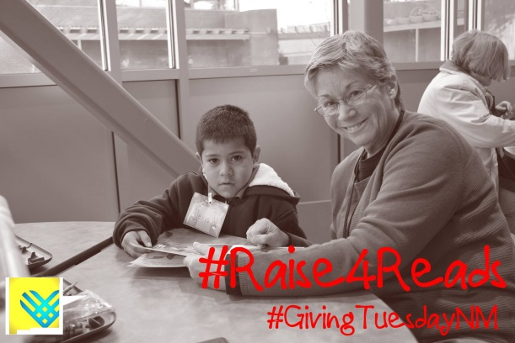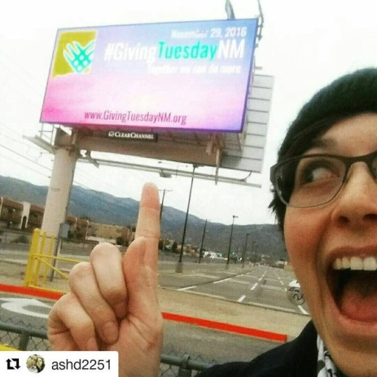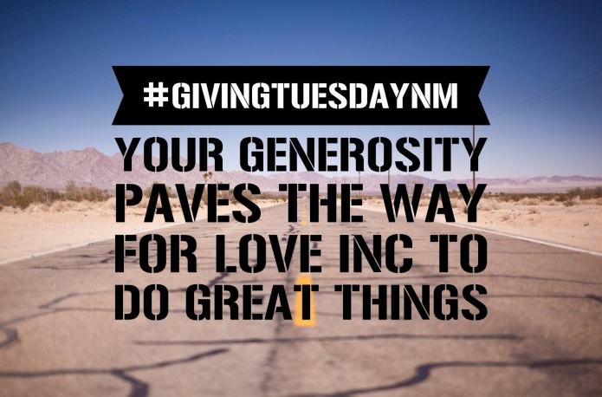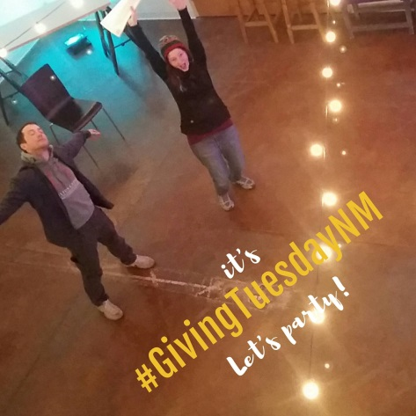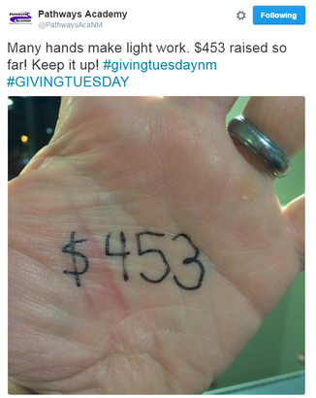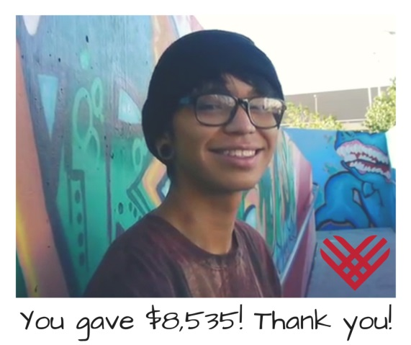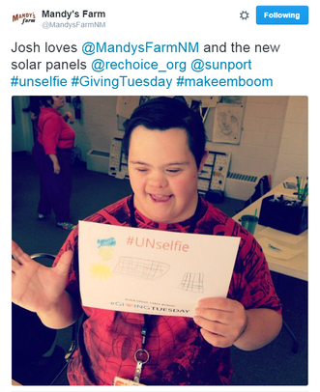

#GivingTuesdayNM

Email Tips

Email Tips
- Set your organization apart.
  - Don’t send templates verbatim – they should serve as a guide, not a blueprint.
  - Remember, the donor and funding community in New Mexico is small, if you use a canned message that another organization has used, the funder or donor will know it.
- Plan your email schedule – always include a call to action!
  - Will you send to all your constituents, donors, newsletter recipients, etc.?
  - Will you send special emails to volunteers, Board members, ambassadors?
- Are you going to send old-fashioned snail mail?
  - Decide who will receive these letters and make sure they are sent in advance.

Sample Email
Challenge or Matching Grant Request

Dear _________,

We are excited to participate in #GivingTuesdayNM to help kick-start [ORGANIZATION NAME]’s giving season. This year #GivingTuesdayNM will be on Tuesday, December 1, 2020, and as you may be aware, is part of the global day of giving known as #GivingTuesday.

I am writing to ask for your help as we are thinking about strategies to leverage donations. Research shows that even a small matching or challenge grant makes a big difference with new, lapsed, and younger donor. Among our key goals on #GivingTuesdayNM is growing our base of constituents for our important work.

As a generous supporter, you know how important our work is to the community. Will you help us spur additional engagement and attract new supporters with a matching or challenge grant?

I would appreciate an opportunity to share with you our specific #GivingTuesdayNM goals that a matching gift would help us to achieve.

Thank you for being one a dedicated supporter. Your giving has a significant impact on our mission to [INSERT PHRASE ABOUT YOUR WORK]. I'll follow up with you to discuss this exciting campaign.

Thank you so much for your commitment to our work!

Sincerely,

[Your Name]
[Your Nonprofit]

Sample Email
Communicating Participation in #GivingTuesdayNM

Dear __________,

This year, on Tuesday, December 1, 2020, [ORGANIZATION NAME] is participating in #GivingTuesdayNM, part of the global day of giving known as #GivingTuesday.

We are excited to be part of the #GivingTuesdayNM coalition this year and invite you to join the movement. You can help by letting your friends, family, and colleagues that #GivingTuesdayNM is coming on December 1.

Here are some ideas for on helping to spread the word:
- Let local elected officials, partner nonprofits, and small businesses know about #GivingTuesdayNM. Encourage them to sign up at www.GivingTuesdayNM.org.
- Use the hashtag #GivingTuesdayNM to talk about the New Mexico nonprofits and causes you care about and support.

The best way to give back to the community in which we live is by coming together to support one another. This can be through dollars, time, or other ways that feels meaningful.

#GivingTuesdayNM is not about just one sector, cause, or community. #GivingTuesdayNM is about New Mexico. Together we can do more.
Thank you,

[Your Name]
[Your Nonprofit]

